PRESS RELEASE
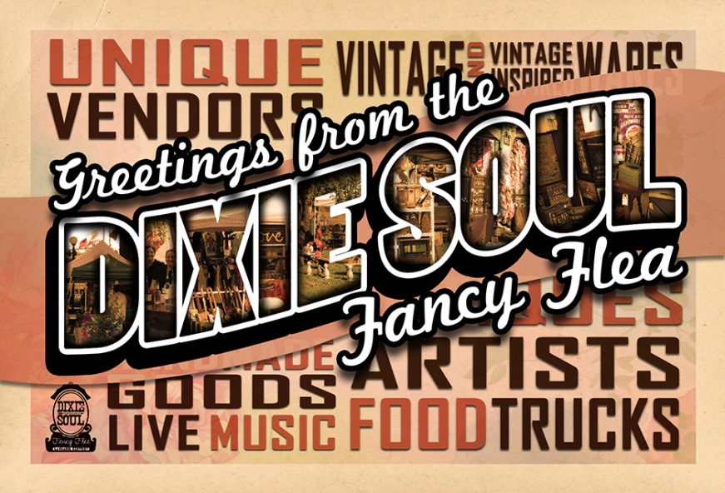
DIXIE SOUL FANCY FLEA IS BACK Y’ALL!
This September 30, 2017 from 10am to 6pm the Dixie Soul Fancy Flea will be back in historic downtown La Grange, Kentucky.
This year, local and out of town vendors will join crowds of excited shoppers under the shady trees of the courthouse lawn. Surrounded by the historic buildings and small town charm of Main Street and the sound of the trains that rumble down the Main Street tracks, shoppers and vendors will experience just how unique this town is.
Come hungry and ready to boogie because the smell of delicious food from nearby food trucks and local restaurants will fill the air, dancing with the sweet notes of the talented musicians playing their hearts out on stage. This year, aside from the usual amazing performers of the Farmers Market, we will be joined by the Oldham County Band, Savannah Dean, and Soul Circus (sponsored by La Grange Service Center)
Signature cocktails will be served up by Classic Cuisine, so hit the bar and have a Main Street Margarita or a Dixie Soul Sangria and say hello to our friendly local bartenders!
Handmade art, vintage wares, clothing, concrete sculptures, unique furniture, tarot readings, and more will fill the booths of the unique vendors joining us this year. There’s no telling what you’ll find.
Unique town, interesting people, amazing wares, delicious food and drinks- what more could you ask for? So come on down y’all, we can’t wait to see you!

